Arista Introduces Open Cloud-Scale Platform
High-radix 12.8Tbps system simplifies 100/400G networking

San Jose, Calif.-March 14, 2019--OCP Global Summit--Arista Networks (NYSE:ANET) today announced the Arista 7360X Series, a radically new and disruptive platform that doubles system density while reducing power consumption and cost. By doubling the network diameter, customers can address the demand for higher bandwidth with reduced leaf-spine tiers while lowering both capex and opex.

Cloud providers now have the ability to migrate to higher performance 100G or 400G while leveraging Arista EOS™ (Extensible Operating System) for single image consistency across the network. The Arista 7368X4 has pioneered the concept of an open platform. It provides choice, scale, customization and efficiency savings that simplify cloud network designs.

“The Arista solution has helped Facebook to gain significant improvements in power and space efficiency, reducing the number of switch chips in the network stack and allowing power to be freed up for compute resources,” said Najam Ahmad, Vice President Network Engineering for Facebook. “Having both an internally developed Minipack and the Arista solution allows Facebook to remain multi-sourced, with an option to run Arista EOS or FBOSS on both, where either system can be deployed in multiple tiers of networks.”

Arista and Facebook engineering teams collaborated in the development of the system, enabling full manageability via FBOSS (Facebook Open Switching Software), controlling power and thermal efficiency along with the control plane.

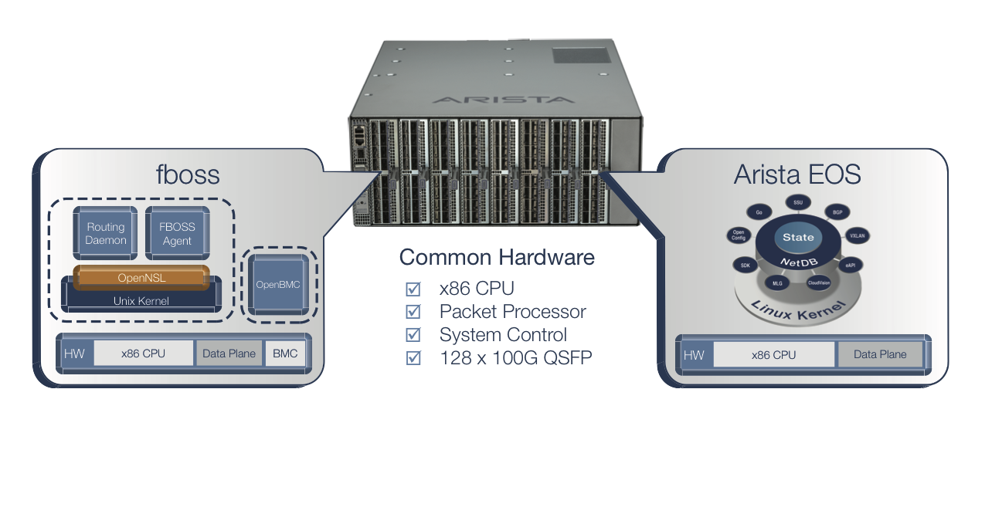

The novel platform is a compact, four unit design and all active components are removable. It delivers a 50% improvement in density compared to traditional modular systems with a 60% reduction in power at under 10 watts per 100G port. Standards-based, the system comes with support for 100G QSFP and 400G OSFP or QSFP-DD optics and cables. Arista EOS delivers the advanced traffic management, automation and telemetry features needed to build and maintain modern cloud networks.

“The Arista 7368X4 Series is a first in the networking industry. The product involved close collaboration by two talented engineering teams, resulting in a better outcome than each team designing in their own silo,” said Anshul Sadana, Chief Operating Officer for Arista Networks.

The Arista 7368X4 Series is available in the following configuration -
8-Slot modular system with a choice of 100G and 400G modules based on industry standard interfaces and support for EOS.

Pricing and Availability

The new high density product is shipping now in volume with 100G interfaces. Price per 100G port is under $600, supporting the growth of 100G and 400G datacenter networks.

About Arista Networks

Arista Networks pioneered software-driven, cognitive cloud networking for large-scale datacenter and campus environments. Arista’s award-winning platforms redefine and deliver availability, agility, automation, analytics, and security. Arista has shipped more than twenty million cloud networking ports worldwide with CloudVision and EOS, an advanced network operating system. Committed to open standards across private, public and hybrid cloud solutions, Arista products are supported worldwide directly and through partners.

ARISTA, EOS, and CloudVision are among the registered and unregistered trademarks of Arista Networks, Inc. in jurisdictions around the world. Other company names or product names may be trademarks of their respective owners. Additional information and resources can be found at www.arista.com. This press release contains forward-looking statements including, but not limited to, statements regarding the benefits and best practices utilized in the design and implementation of Arista's EOS and CloudVision software and the enablement of cost savings, security capabilities, more performance and efficiency. All statements other than statements of historical fact are statements that could be deemed forward-looking statements. Forward-looking statements are subject to risks and uncertainties that could cause actual performance or results to differ materially from those expressed in the forward-looking statements including: our limited operating history and experience with developing and releasing new products; product, support or service quality problems; rapidly evolving changes in technology, customer requirements and industry standards as well as other risks stated in our filings with the SEC available on Arista's website at www.arista.com and the SEC's website at www.sec.gov. Arista disclaims any obligation to publicly update or revise any forward-looking statement to reflect events that occur or circumstances that exist after the date on which they were made.

Media Contact
Amanda Jaramillo
Corporate Communications
Tel: (408) 547-5798
amanda@arista.com

Investor Contact
Charles Yager
Product and Investor Advocacy
Tel: (408) 547-5892
cyager@arista.com

